Deidre Supanich
Tasha Candela
Career Field Experience
November 26, 2016
Vintage House
“You don’t have to cook fancy or complicated masterpieces, just good from fresh ingredients” – Julia Child. This relates to my placement because everything was posh but classic and delicious minus the ridiculous names like Crème brûlée. The second most important moral in Vintage House besides don’t waste food, was fresh ingredients are a must for every dish. In my Career Field Experience class, I was required to work in a kitchen for at least 5 hours, share my new found knowledge on my Weebly, and take on whatever skills I could learn. Personally I feel Career Field Experience is a unique class because it gave me a real feeling of what the culinary industry is like. Being in a class that teaches you how to cook and actually working in a real kitchen are two completely different things, I would have never gotten into that kitchen at my age if it weren’t for this class. For thirteen weeks, I spent my time with amazing people who have been in this industry together for years and were more than willing to show me the ropes. I experienced so much here, I didn’t even know I was holding a knife wrong until I stepped into this kitchen. Turns out you’re more likely to chop off your fingers if you don’t have your index finger over the top of the blade. I got to use many kitchen instruments I don’t have at home which was always exciting. I learned how to chop vegetables in a fancy matter and how to present the food as well which makes dinner at home more fun. Working with older chefs who have been in the industry has taught me three employability skills of teamwork, adaptability, and problem solving allowing me to grow as a professional.
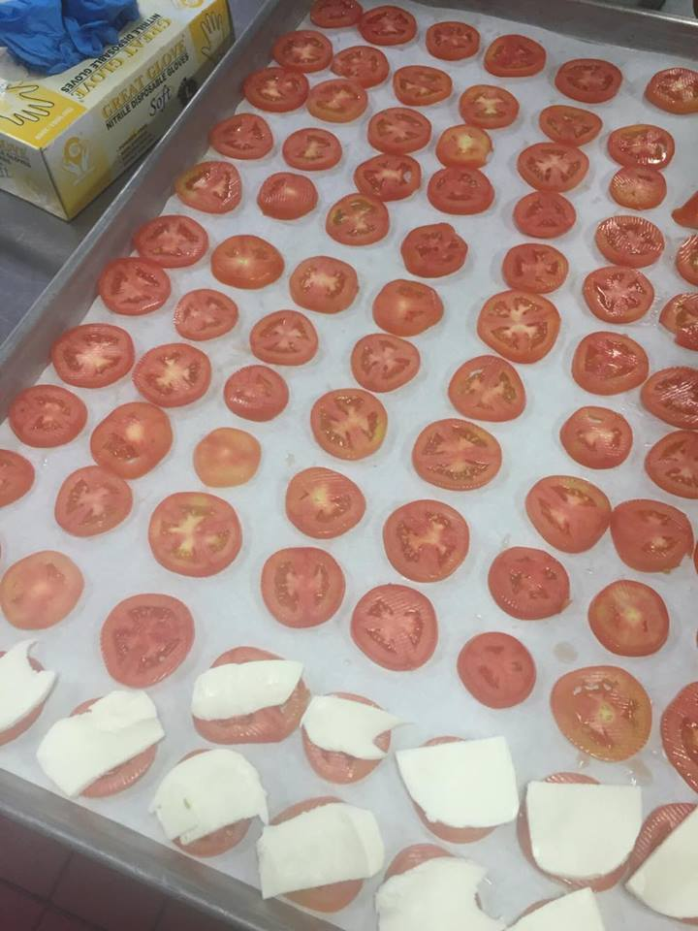
Teamwork
Teamwork is a huge part of the kitchen, if you don’t work well with others than you will fail. Everybody has their own task to do to bring the whole meal together. I noticed most of the chefs had their own engagements they would do every day. For example there was a wonderful man who was always on vegetable duty, his knife skills were amazing he could chop everything so fast and it would all come out perfect. Whenever I would shadow him he’d chop the vegetables for salads and I’d put them together to make the process go faster. When we would serve the meals we all had stations, everybody either garnished the dished or put them on a plate. Working as a team with these chefs has made me realize not every task can be done on your own and things go faster when you have a group of people supporting and helping each other.
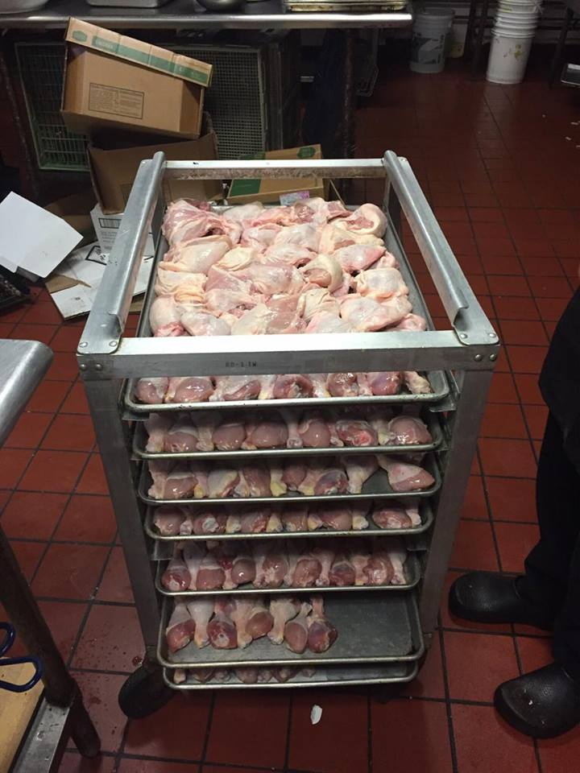
Adaptability
Adaptability is a big part of the kitchen, one day you’ll be chopping vegetables, the next your slicing meat. Also in my placement, you never know who you are going to be shadowing until you get to work. You have to be able to handle challenges, not doing the same thing every day, and be able to watch anyone and learn from them. Being able to adapt from a calm kitchen of merely chopping vegetables to hectic servers running around to serve food is also something you have to get use to very fast. New tools were given to me every day and it made things different, sometimes it was easier, other times it was harder. This taught me to accept change and be able to adapt fast to get my work done.
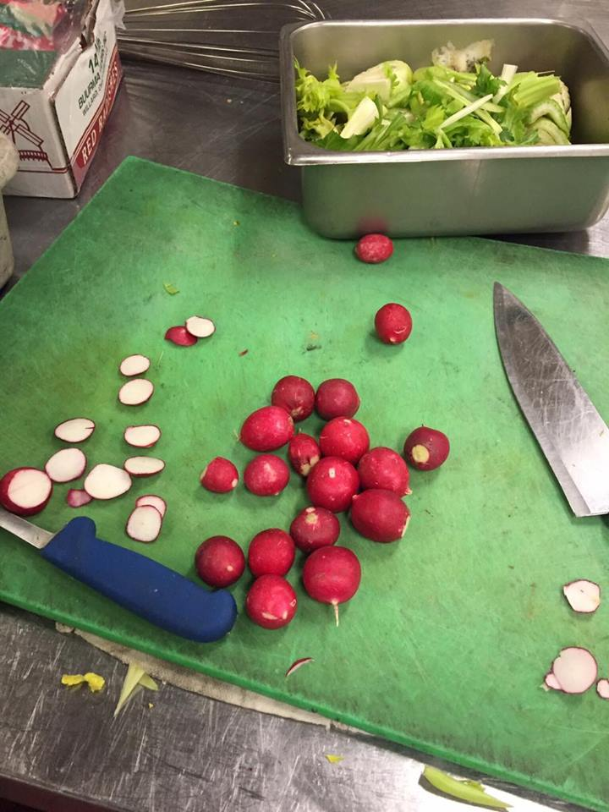
Problem Solving
Problem solving was used every day in the kitchen. Supplements for ingredients, running out of butter, figuring out how many pieces of food is on a pan trying to figure out a quick and easy way to count them up are all examples of this. Within my last two weeks on of the days I came in I was on bun duty. Before you put the buns on the tray you have to butter them up, the only problem was, there was no butter left. Pay Lay, the chef I was shadowing, came up with the great idea of putting butter sauce on them then wiping off access butter with a napkin. Another time was trying to figure out how to cut bread at the same angel and equal sizes. It took me a good 5 tries but eventually I figured by putting the bread at an angle and leaving my knife normal I could cut them at the same angle. To eliminate the problem of the bread slices being different widths I used a piece of bread to mark where to cut.
Final Evaluation Reflection
My final evaluation sheet is very satisfactory, I got all 5’s and 4’s with a couple of no answers. The only 3 I got was finishing tasks on time, I did take a bit of time to wrap my head around tasks so I’m not too surprised for that one. That is my biggest weakness wasting time trying to figure out how to come at a task. One of my strengths is being able to maintain a professional attitude. Being the only rooky in the kitchen is a bit of pressure considering everyone else has been in the industry for years. I’m proud of myself for Chef Shannon giving me a 5 on my professionalism, I always tried to act more mature and business like. Review your final evaluation.
Conclusion
This class changed me as a person because it made me tougher. Usually when I’m put in a room of strangers I get very shy and timid. This class made me realize if I have a question that needs to be asked I should do so without feeling embarrassed. Also people don’t get mad when you ask questions and being quite around strangers is boring, you can learn a lot for them. I will never forget Pay Lay, he was my favorite chef, I feel bad because I never learned how to spell his name right, but he will always be my favorite memory from Vintage house. He was always kind to me and helped me in every way he could but managed to crack jokes every couple’s minutes. He was hilarious and very patient, I looked forward to seeing him at word. Pay Lay also made sure I ate every time I went in, at least attempted, which I saw as very sweet. I look up to him and Chef Shannon the most at Vintage house and it was an honor to meet them. I would recommend this experience to a friend because it gives you a real feeling of what your future is going to be like. If you are uncertain that whatever you want to do after high school is right for you why not try it while you’re still in high school and be able to switch careers before it’s too late. My next steps to pursuing my dreams is to enroll in culinary and business classes after high school. Having a degree in the industry makes things go much smoother.

